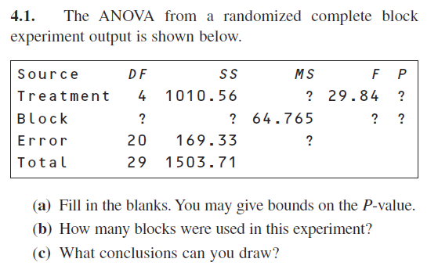

**SOLUTION**

|  |  |  |  |  |  |  |
| --- | --- | --- | --- | --- | --- | --- |
| **Source** | **DF** | **SS** | **MS** | **F\*** | $$F_{4,20, ∝=.05}$$ | **P-Value** |
| Treatment | 4 | 1010.56 | 252.64 | 29.84 | 2.87 | P < 0.05 |
| Block | 5 | 323.82 | 64.765 | 7.65 | 2.87 | P < 0.05 |
| Error | 20 | 169.33 | 8.467 |  |  |  |
| Total | 29 | 1503.71 |  |  |  |  |

1. 6 blocks were used in this experiment. We can tell from the degrees of freedom of block. 5 + 1 = 6
2. From the above ANOVA table we can conclude that both treatment and block are significant. Treatment has a F critical value of 29.84 and Block has a F critical value of 7.65. Both of these values are larger than the F table value with 4 and 20 degrees of freedom with alpha level of 0.05

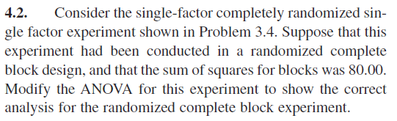

**Solution**

|  |  |  |  |  |
| --- | --- | --- | --- | --- |
| **Source** | **DF** | **SS** | **MS** | **F\*** |
| Treatment | 4 | 987.71 | 246.93 | 33.10 |
| Error | 25 | 186.53 | 7.46 |  |
| Total | 29 | 1174.24 |  |  |

|  |  |  |  |  |  |  |
| --- | --- | --- | --- | --- | --- | --- |
| **Source** | **DF** | **SS** | **MS** | **F\*** | $$F_{4,20, ∝=.05}$$ | **P-Value** |
| Treatment | 4 | 987.71 | 246.93 | 46.328 | 2.87 | P < 0.05 |
| Block | 5 | 80 | 16 | 3.002 | 2.87 | P < 0.05 |
| Error | 20 | 106.53 | 5.33 |  |  |  |
| Total | 29 | 1174.24 |  |  |  |  |

a = 5, N = 30, b = 6

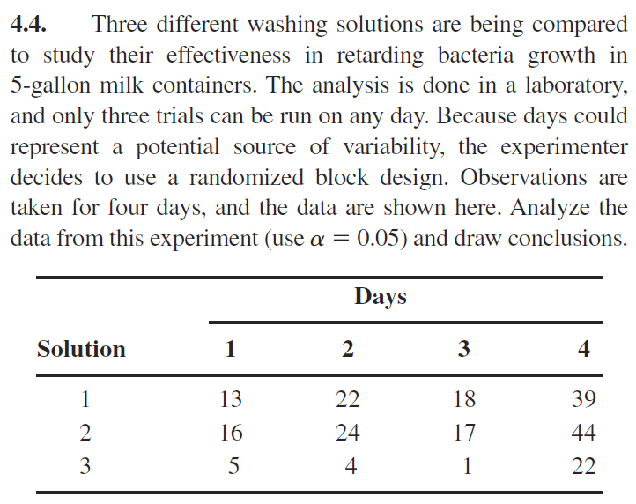

We have the following hypothesis

$$H_{0}: τ_{i}=0, ∀i=1, 2, 3 vs H_{a}:at least one τ ≠0$$

|  |
| --- |
| ***RCBD for Bacteria Growth Experiment*** |
| ***y = Growth, x1 = Solution (treatment), x2 = Day (block)*** |

|  |
| --- |
| ***The GLM Procedure*** |

|  |
| --- |
| ***Dependent Variable: y Growth*** |

| **Source** | **DF** | **Sum of Squares** | **Mean Square** | **F Value** | **Pr > F** |
| --- | --- | --- | --- | --- | --- |
| **Model** | 5 | 1810.416667 | 362.083333 | 41.91 | 0.0001 |
| **Error** | 6 | 51.833333 | 8.638889 |  |  |
| **Corrected Total** | 11 | 1862.250000 |  |  |  |

| **Source** | **DF** | **Type III SS** | **Mean Square** | **F Value** | **Pr > F** |
| --- | --- | --- | --- | --- | --- |
| **x1** | 2 | 703.500000 | 351.750000 | 40.72 | 0.0003 |
| **x2** | 3 | 1106.916667 | 368.972222 | 42.71 | 0.0002 |

From the above SAS output we can see that the F-Statistic for Treatment is 40.72 with 2 and 6 degrees of freedom. The corresponding P-Value is less than α = 0.05 so we can conclude that the solution used has a significant effect on bacteria growth.

Additionally, we can see that the F-Statistic for Block Effect is 42.71 with 3 and 6 degrees of freedom. The corresponding P-Value is less than α = 0.05 so we can conclude that the day effect is significant.

**MODEL CHECKING**



| **Levene's Test for Homogeneity of y Variance ANOVA of Squared Deviations from Group Means** | | | | | |
| --- | --- | --- | --- | --- | --- |
| **Source** | **DF** | **Sum of Squares** | **Mean Square** | **F Value** | **Pr > F** |
| **x1** | 2 | 7013.1 | 3506.5 | 0.24 | 0.7948 |
| **Error** | 9 | 133963 | 14884.8 |  |  |

| **Levene's Test for Homogeneity of y Variance ANOVA of Squared Deviations from Group Means** | | | | | |
| --- | --- | --- | --- | --- | --- |
| **Source** | **DF** | **Sum of Squares** | **Mean Square** | **F Value** | **Pr > F** |
| **x2** | 3 | 8105.6 | 2701.9 | 0.78 | 0.5391 |
| **Error** | 8 | 27824.8 | 3478.1 |  |  |







From the above SAS generated interaction plot we can see parallel movement between the variables which indicates that there is no significant interaction between the solution used and the day the experiment was conducted.

The above residual plots indicate that variance is constant, this is reinforced by the Levene Tests. The Levene’s tests for Homogeneity of Variance for both Solution and Day have a F-Statistics of 0.24 with 2 and 9 degrees of freedom and 0.78 with 3 and 8 degrees of freedom respectively. Both of these tests have P-Values > α = 0.05 which indicates that the variance for Solution and Day are constant.

|  |
| --- |
| ***Normal Test for Bacteria Growth Experiment*** |
| ***y = Growth, x1 = Solution (treatment), x2 = Day (block)*** |

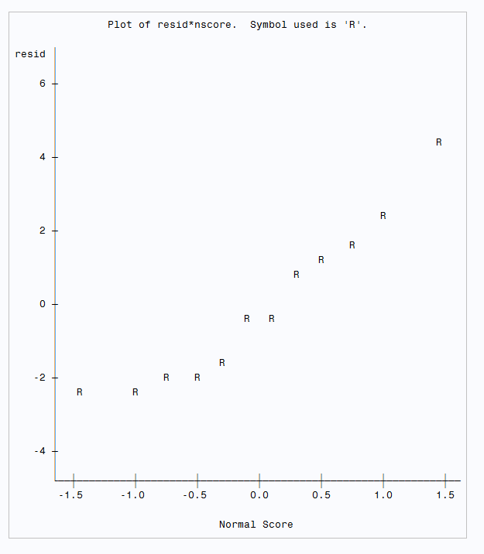

| **Tests for Normality** | | | | |
| --- | --- | --- | --- | --- |
| **Test** | **Statistic** | | **p Value** | |
| **Shapiro-Wilk** | **W** | 0.932079 | **Pr < W** | 0.4027 |
| **Kolmogorov-Smirnov** | **D** | 0.171886 | **Pr > D** | >0.1500 |
| **Cramer-von Mises** | **W-Sq** | 0.048148 | **Pr > W-Sq** | >0.2500 |
| **Anderson-Darling** | **A-Sq** | 0.32797 | **Pr > A-Sq** | >0.2500 |

From the above SAS normality tests, we can see that the normality tests have a P -Value > α = 0.05. From these tests and the above normality plot we can conclude that the residuals are normally distributed.

Since there is no interaction present in our model, and the residuals are normally distributed with constant variance we can conclude that all the model assumptions are satisfied. Thus, CRBD is a valid model to use. We will continue with multiple comparison.

|  |
| --- |
| ***RCBD for Bacteria Growth Experiment*** |
| ***y = Growth, x1 = Solution (treatment), x2 = Day (block)*** |

|  |
| --- |
| ***The GLM Procedure*** |

|  |
| --- |
| ***Tukey's Studentized Range (HSD) Test for y*** |

|  |  |
| --- | --- |
| **Alpha** | 0.05 |
| **Error Degrees of Freedom** | 6 |
| **Error Mean Square** | 8.638889 |
| **Critical Value of Studentized Range** | 4.33917 |
| **Minimum Significant Difference** | 6.3768 |

| **Comparisons significant at the 0.05 level are indicated by ***.** | | | | |
| --- | --- | --- | --- | --- |
| **x1 Comparison** | **Difference Between Means** | **Simultaneous 95% Confidence Limits** | |  |
| **2 - 1** | 2.250 | -4.127 | 8.627 |  |
| **2 - 3** | 17.250 | 10.873 | 23.627 | *** |
| **1 - 2** | -2.250 | -8.627 | 4.127 |  |
| **1 - 3** | 15.000 | 8.623 | 21.377 | *** |
| **3 - 2** | -17.250 | -23.627 | -10.873 | *** |
| **3 - 1** | -15.000 | -21.377 | -8.623 | *** |

From the above Tukey test and the attached do by hand we can see that MSD is 6.3768 with a q-critical value of 4.34 with 3 and 6 degrees of freedom. From this we can conclude that there is no statistical difference between $\overline{Y_{1.}} and {\overline{Y}}_{2.}$

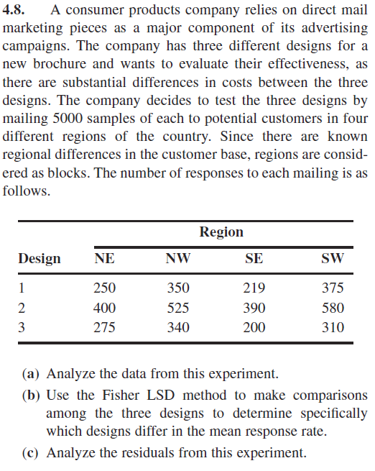

$$H_{0}: τ_{i}=0, ∀i=1, 2, 3 vs H_{a}:at least one τ ≠0$$

|  |
| --- |
| ***RCBD for Brochure Design*** |
| ***y = Response Number, x1 = Design (treatment), x2 = Region (block)*** |
| ***Region: 1 = NE 2 = NW 3 = SE 4 = SW*** |

|  |
| --- |
| ***The GLM Procedure*** |

|  |
| --- |
| ***Dependent Variable: y Response*** |

| **Source** | **DF** | **Sum of Squares** | **Mean Square** | **F Value** | **Pr > F** |
| --- | --- | --- | --- | --- | --- |
| **Model** | 5 | 139790.8333 | 27958.1667 | 30.90 | 0.0003 |
| **Error** | 6 | 5428.8333 | 904.8056 |  |  |
| **Corrected Total** | 11 | 145219.6667 |  |  |  |

| **Source** | **DF** | **Type III SS** | **Mean Square** | **F Value** | **Pr > F** |
| --- | --- | --- | --- | --- | --- |
| **x1** | 2 | 90755.16667 | 45377.58333 | 50.15 | 0.0002 |
| **x2** | 3 | 49035.66667 | 16345.22222 | 18.06 | 0.0021 |

From the above SAS output we can see that the F-Statistic for Treatment is 50.15 with 2 and 6 degrees of freedom. The corresponding P-Value is less than α = 0.05 so we can conclude that the brochure design used has a significant effect on the response rate.

Additionally, we can see that the F-Statistic for Block is 18.06 with 3 and 6 degrees of freedom. The corresponding P-Value is less than α = 0.05 so we can conclude that the region block has a significant effect on response rate.

|  |
| --- |
| ***RCBD for Brochure Design*** |
| ***y = Response Number, x1 = Design (treatment), x2 = Region (block)*** |
| ***Region: 1 = NE 2 = NW 3 = SE 4 = SW*** |

|  |
| --- |
| ***The GLM Procedure*** |

|  |
| --- |
| ***t Tests (LSD) for y*** |

|  |  |
| --- | --- |
| **Alpha** | 0.05 |
| **Error Degrees of Freedom** | 6 |
| **Error Mean Square** | 904.8056 |
| **Critical Value of t** | 2.44691 |
| **Least Significant Difference** | 52.045 |

| **Comparisons significant at the 0.05 level are indicated by ***.** | | | | |
| --- | --- | --- | --- | --- |
| **x1 Comparison** | **Difference Between Means** | **95% Confidence Limits** | |  |
| **2 - 1** | 175.25 | 123.20 | 227.30 | *** |
| **2 - 3** | 192.50 | 140.45 | 244.55 | *** |
| **1 - 2** | -175.25 | -227.30 | -123.20 | *** |
| **1 - 3** | 17.25 | -34.80 | 69.30 |  |
| **3 - 2** | -192.50 | -244.55 | -140.45 | *** |
| **3 - 1** | -17.25 | -69.30 | 34.80 |  |

From the above SAS output and the attached do by hand we can see that according to Fisher LSD $\overline{Y_{1.}} and {\overline{Y}}_{3.}$ are not significantly different

**MODEL CHECKING**







| **Levene's Test for Homogeneity of y Variance ANOVA of Squared Deviations from Group Means** | | | | | |
| --- | --- | --- | --- | --- | --- |
| **Source** | **DF** | **Sum of Squares** | **Mean Square** | **F Value** | **Pr > F** |
| **x1** | 2 | 30196372 | 15098186 | 1.73 | 0.2318 |
| **Error** | 9 | 78667927 | 8740881 |  |  |

| **Levene's Test for Homogeneity of y Variance ANOVA of Squared Deviations from Group Means** | | | | | |
| --- | --- | --- | --- | --- | --- |
| **Source** | **DF** | **Sum of Squares** | **Mean Square** | **F Value** | **Pr > F** |
| **x2** | 3 | 1.2659E8 | 42197236 | 0.75 | 0.5512 |
| **Error** | 8 | 4.4877E8 | 56096158 |  |  |

From the above SAS generated interaction plot we can observe parallel movement between the variables which indicates that there is no significant interaction between the solution used and the day the experiment was conducted.

The above Levene’s tests for Homogeneity of Variance for both Design and Region have a F-Statistics of 0.1.73 with 2 and 9 degrees of freedom and 0.75 with 3 and 8 degrees of freedom respectively. Both of these tests have P-Values > α = 0.05 which indicates that the variance for Design and Region are constant.

|  |
| --- |
| ***Normal Tests for Brochure Design*** |
| ***y = Response Number, x1 = Design (treatment), x2 = Region (block)*** |
| ***Region: 1 = NE 2 = NW 3 = SE 4 = SW*** |

| **Tests for Normality** | | | | |
| --- | --- | --- | --- | --- |
| **Test** | **Statistic** | | **p Value** | |
| **Shapiro-Wilk** | **W** | 0.888673 | **Pr < W** | 0.1133 |
| **Kolmogorov-Smirnov** | **D** | 0.232665 | **Pr > D** | 0.0725 |
| **Cramer-von Mises** | **W-Sq** | 0.141938 | **Pr > W-Sq** | 0.0252 |
| **Anderson-Darling** | **A-Sq** | 0.729439 | **Pr > A-Sq** | 0.0429 |

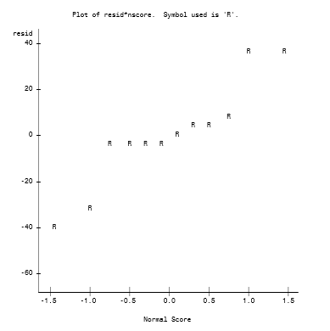

From the above normality plot we might conclude that the residuals are not normally distributed. However, we can see that the Shapiro-Wilk test for Normality has a P-Value = 0.1133 > α = 0.05. This indicates that the residuals of our normally distributed.

Since there is no interaction in our model and the variance is normally distributed with constant variance we can conclude that this is an appropriate model. We will continue with the multiple comparison using Tukey.

|  |
| --- |
| ***RCBD for Brochure Design*** |
| ***y = Response Number, x1 = Design (treatment), x2 = Region (block)*** |
| ***Region: 1 = NE 2 = NW 3 = SE 4 = SW*** |

|  |
| --- |
| ***Tukey's Studentized Range (HSD) Test for y*** |

|  |  |
| --- | --- |
| **Alpha** | 0.05 |
| **Error Degrees of Freedom** | 6 |
| **Error Mean Square** | 904.8056 |
| **Critical Value of Studentized Range** | 4.33917 |
| **Minimum Significant Difference** | 65.261 |

| **Comparisons significant at the 0.05 level are indicated by ***.** | | | | |
| --- | --- | --- | --- | --- |
| **x1 Comparison** | **Difference Between Means** | **Simultaneous 95% Confidence Limits** | |  |
| **2 - 1** | 175.25 | 109.99 | 240.51 | *** |
| **2 - 3** | 192.50 | 127.24 | 257.76 | *** |
| **1 - 2** | -175.25 | -240.51 | -109.99 | *** |
| **1 - 3** | 17.25 | -48.01 | 82.51 |  |
| **3 - 2** | -192.50 | -257.76 | -127.24 | *** |
| **3 - 1** | -17.25 | -82.51 | 48.01 |  |

From the above Tukey test and the attached do by hand we can see that MSD is 65.261 with a q-critical value of 4.34 with 3 and 6 degrees of freedom. From this we can conclude that there is no statistical difference between $\overline{Y_{1.}} and {\overline{Y}}_{3.}$. We should note that this matches the conclusion we get using Fisher LSD for the multiple comparison.

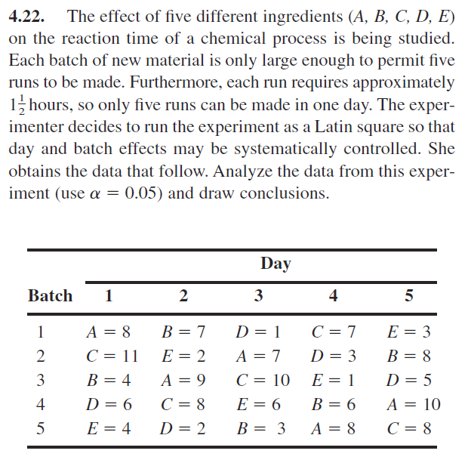

$$H_{0}: τ_{i}=0, ∀i=1, 2, 3, 4, 5 vs H_{a}:at least one τ ≠0$$

|  |
| --- |
| ***Latin Square for Reaction Time Experiment*** |
| ***y = Reaction Time, x1 = Ingredient, x2 = Batch, x3 = Day*** |

|  |
| --- |
| ***The GLM Procedure*** |

|  |
| --- |
| ***Dependent Variable: y Reaction Time*** |

| **Source** | **DF** | **Sum of Squares** | **Mean Square** | **F Value** | **Pr > F** |
| --- | --- | --- | --- | --- | --- |
| **Model** | 12 | 169.1200000 | 14.0933333 | 4.51 | 0.0072 |
| **Error** | 12 | 37.5200000 | 3.1266667 |  |  |
| **Corrected Total** | 24 | 206.6400000 |  |  |  |

| **Source** | **DF** | **Type III SS** | **Mean Square** | **F Value** | **Pr > F** |
| --- | --- | --- | --- | --- | --- |
| **x1** | 4 | 141.4400000 | 35.3600000 | 11.31 | 0.0005 |
| **x2** | 4 | 15.4400000 | 3.8600000 | 1.23 | 0.3476 |
| **x3** | 4 | 12.2400000 | 3.0600000 | 0.98 | 0.4550 |

From the above SAS output we can see that the F-Statistic for Treatment is 11.31 with 4 and 12 degrees of freedom. The corresponding P-Value is less than α = 0.05 so we can conclude that the ingredient used has a significant effect on the reaction time.

Additionally, we can see that the F-Statistic for batch effect is 1.23 with 4 and 12 degrees of freedom. The corresponding P-Value is larger than α = 0.05 so we can conclude that the batch has no significant effect on reaction time.

Furthermore, we can see that the F-Statistic for day is 0.98 with 4 and 12 degrees of freedom. The corresponding P-Value is larger than α = 0.05 so we can conclude that the day effect has no significant effect on reaction time.

**MODEL CHECKING**

|  |
| --- |
| ***Interaction Plot for Reaction Time Experiment*** |
| ***y = Reaction Time, x1 = Ingredient, x2 = Batch, x3 = Day*** |

|  |
| --- |
| ***The GLM Procedure*** |

|  |
| --- |
| ***Dependent Variable: y Reaction Time*** |







From the above SAS generated interaction plot we can observe parallel movement between the variables which indicates that there is no significant interaction between the ingredients used the batch number and the day the experiment was conducted.







| **Levene's Test for Homogeneity of y Variance ANOVA of Squared Deviations from Group Means** | | | | | |
| --- | --- | --- | --- | --- | --- |
| **Source** | **DF** | **Sum of Squares** | **Mean Square** | **F Value** | **Pr > F** |
| **x1** | 4 | 20.8384 | 5.2096 | 0.85 | 0.5099 |
| **Error** | 20 | 122.5 | 6.1240 |  |  |

| **Levene's Test for Homogeneity of y Variance ANOVA of Squared Deviations from Group Means** | | | | | |
| --- | --- | --- | --- | --- | --- |
| **Source** | **DF** | **Sum of Squares** | **Mean Square** | **F Value** | **Pr > F** |
| **x2** | 4 | 247.3 | 61.8336 | 1.30 | 0.3036 |
| **Error** | 20 | 951.1 | 47.5536 |  |  |

| **Levene's Test for Homogeneity of y Variance ANOVA of Squared Deviations from Group Means** | | | | | |
| --- | --- | --- | --- | --- | --- |
| **Source** | **DF** | **Sum of Squares** | **Mean Square** | **F Value** | **Pr > F** |
| **x3** | 4 | 49.8176 | 12.4544 | 0.26 | 0.9030 |
| **Error** | 20 | 975.7 | 48.7856 |  |  |

The above Levene’s tests for Homogeneity of Variance for both Design and Region have a F-Statistics of 0.1.73 with 2 and 9 degrees of freedom and 0.75 with 3 and 8 degrees of freedom respectively. Both tests have P-Values > α = 0.05 which indicates that the variance for Design and Region are constant.

|  |
| --- |
| ***Normal Tests for Latin Square for Reaction Time Experiment*** |
| ***y = Reaction Time, x1 = Ingredient, x2 = Batch, x3 = Day*** |

| **Tests for Normality** | | | | |
| --- | --- | --- | --- | --- |
| **Test** | **Statistic** | | **p Value** | |
| **Shapiro-Wilk** | **W** | 0.966058 | **Pr < W** | 0.5476 |
| **Kolmogorov-Smirnov** | **D** | 0.119337 | **Pr > D** | >0.1500 |
| **Cramer-von Mises** | **W-Sq** | 0.05717 | **Pr > W-Sq** | >0.2500 |
| **Anderson-Darling** | **A-Sq** | 0.34711 | **Pr > A-Sq** | >0.2500 |

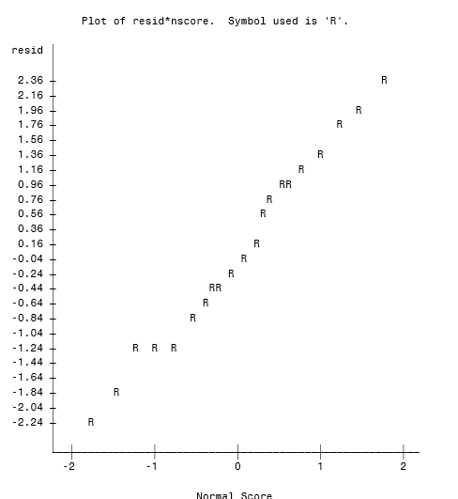

From the above SAS output we can see that the residuals are normally distributed. The above normality plot looks linear and this is confirmed by the Shapiro-Wilks test which has a P-Value of 0.6476 which is larger than 0.05.

Since the model has no interaction with residuals normally distributed with equal variance we can conclude that this is an appropriate model. We will continue the analysis with Tukey multiple comparison.

|  |
| --- |
| ***Latin Square for Reaction Time Experiment*** |
| ***y = Reaction Time, x1 = Ingredient, x2 = Batch, x3 = Day*** |

|  |  |  |
| --- | --- | --- |
| ***Tukey's Studentized Range (HSD) Test for y*** | | |
| **Alpha** | | 0.05 |
| **Error Degrees of Freedom** | | 12 |
| **Error Mean Square** | | 3.126667 |
| **Critical Value of Studentized Range** | | 4.50766 |
| **Minimum Significant Difference** | | 3.5646 |

| **Comparisons significant at the 0.05 level are indicated by ***.** | | | | |
| --- | --- | --- | --- | --- |
| **x1 Comparison** | **Difference Between Means** | **Simultaneous 95% Confidence Limits** | |  |
| **A - B** | 2.800 | -0.765 | 6.365 |  |
| **A - C** | -0.400 | -3.965 | 3.165 |  |
| **A - D** | 5.000 | 1.435 | 8.565 | *** |
| **A - E** | 5.200 | 1.635 | 8.765 | *** |
| **B - C** | -3.200 | -6.765 | 0.365 |  |
| **B - D** | 2.200 | -1.365 | 5.765 |  |
| **B - E** | 2.400 | -1.165 | 5.965 |  |
| **C - D** | 5.400 | 1.835 | 8.965 | *** |
| **C - E** | 5.600 | 2.035 | 9.165 | *** |
| **D - E** | 0.200 | -3.365 | 3.765 |  |

From the above Tukey test we can see that the q-critical value is 4.51 with 4 and 12 degrees of freedom. Looking at the results we can conclude that the level difference between A-D, A-E, C-D, C-E are significant. All others do not exceed Tukey’s MSD = 3.56.

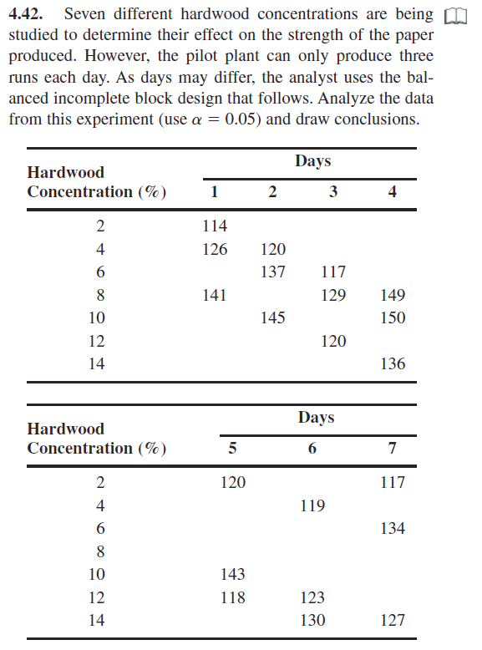

|  |
| --- |
| ***BIBD for Hardwood Concentration Percent Experiment*** |
| ***y = Strength x1 = Hardwood Concentration % x2 = Days*** |

|  |
| --- |
| ***Dependent Variable: y Strength*** |

| **Source** | **DF** | **Sum of Squares** | **Mean Square** | **F Value** | **Pr > F** |
| --- | --- | --- | --- | --- | --- |
| **Model** | 12 | 2431.714286 | 202.642857 | 9.62 | 0.0017 |
| **Error** | 8 | 168.571429 | 21.071429 |  |  |
| **Corrected Total** | 20 | 2600.285714 |  |  |  |

| **Source** | **DF** | **Type I SS** | **Mean Square** | **F Value** | **Pr > F** |
| --- | --- | --- | --- | --- | --- |
| **x2** | 6 | 1114.285714 | 185.714286 | 8.81 | 0.0036 |
| **x1** | 6 | 1317.428571 | 219.571429 | 10.42 | 0.0021 |

From the above SAS output we can see that the F-Statistic for Hardwood Concentration is 10.42 with 6 and 8 degrees of freedom. The corresponding P-Value is less than α = 0.05 so we can conclude that the Hardwood Concentration used has a significant effect on the paper strength.

Additionally, we can see that the F-Statistic for day effect is 8.81 with 6 and 8 degrees of freedom. The corresponding P-Value is smaller than α = 0.05 so we can conclude that the day effect is significant.

Furthermore, we can see that the F-Statistic for day is 0.98 with 4 and 12 degrees of freedom. The corresponding P-Value is larger than α = 0.05 so we can conclude that the day effect has no significant effect on reaction time.

**MODEL CHECKING**

|  |
| --- |
| ***BIBD for Hardwood Concentration Percent Experiment*** |
| ***y = Strength x1 = Hardwood Concentration % x2 = Days*** |



From the above SAS generated interaction plot we can observe parallel movement between the variables which indicates that there is no significant interaction between the Hardwood Percentage or the day the experiment was conducted.

| **Levene's Test for Homogeneity of y Variance ANOVA of Squared Deviations from Group Means** | | | | | |
| --- | --- | --- | --- | --- | --- |
| **Source** | **DF** | **Sum of Squares** | **Mean Square** | **F Value** | **Pr > F** |
| **x1** | 6 | 17908.7 | 2984.8 | 2.53 | 0.0712 |
| **Error** | 14 | 16492.3 | 1178.0 |  |  |

| **Levene's Test for Homogeneity of y Variance ANOVA of Squared Deviations from Group Means** | | | | | |
| --- | --- | --- | --- | --- | --- |
| **Source** | **DF** | **Sum of Squares** | **Mean Square** | **F Value** | **Pr > F** |
| **x2** | 6 | 39966.5 | 6661.1 | 1.29 | 0.3253 |
| **Error** | 14 | 72559.3 | 5182.8 |  |  |



The above Levene’s tests for Homogeneity of Variance for both Hardwood Concentration and Days have a F-Statistics of 0.0712 with 6 and 14 degrees of freedom and 0.3253 with 6 and 14degrees of freedom respectively. Both tests have P-Values > α = 0.05 which indicates that the variance for Hardwood Concentration and Days are constant.

**MULTIPLE COMPARISON**

|  |
| --- |
| ***BIBD for Hardwood Concentration Percent Experiment*** |
| ***y = Strength x1 = Hardwood Concentration % x2 = Days*** |

|  |  |  |
| --- | --- | --- |
| ***Tukey's Studentized Range (HSD) Test for y*** | | |
|  | | |
| **Alpha** | | 0.05 |
| **Error Degrees of Freedom** | | 8 |
| **Error Mean Square** | | 21.07143 |
| **Critical Value of Studentized Range** | | 5.39904 |
| **Minimum Significant Difference** | | 14.309 |

| **Comparisons significant at the 0.05 level are indicated by ***.** | | | | |
| --- | --- | --- | --- | --- |
| **x1 Comparison** | **Difference Between Means** | **Simultaneous 95% Confidence Limits** | |  |
| **10 – 14** | 15.000 | 0.691 | 29.309 | *** |
| **10 – 12** | 25.667 | 11.358 | 39.975 | *** |
| **8 - 10** | -6.333 | -20.642 | 7.975 |  |
| **8 - 14** | 8.667 | -5.642 | 22.975 |  |
| **8 - 12** | 19.333 | 5.025 | 33.642 | *** |
| **6 - 10** | -16.667 | -30.975 | -2.358 | *** |
| **6 - 8** | -10.333 | -24.642 | 3.975 |  |
| **6 - 14** | -1.667 | -15.975 | 12.642 |  |
| **6 - 12** | 9.000 | -5.309 | 23.309 |  |
| **4 - 10** | -24.333 | -38.642 | -10.025 | *** |
| **4 - 8** | -18.000 | -32.309 | -3.691 | *** |
| **4 - 14** | -9.333 | -23.642 | 4.975 |  |
| **4 - 6** | -7.667 | -21.975 | 6.642 |  |
| **4 - 12** | 1.333 | -12.975 | 15.642 |  |
| **12 – 14** | -10.667 | -24.975 | 3.642 |  |
| **2 - 10** | -29.000 | -43.309 | -14.691 | *** |
| **2 - 8** | -22.667 | -36.975 | -8.358 | *** |
| **2 - 14** | -14.000 | -28.309 | 0.309 |  |
| **2 - 6** | -12.333 | -26.642 | 1.975 |  |
| **2 - 4** | -4.667 | -18.975 | 9.642 |  |
| **2 - 12** | -3.333 | -17.642 | 10.975 |  |

From the above Tukey test we can see that the q-critical value is 5.399 with 7 and 8 degrees of freedom. Looking at the results we can conclude that the level difference between 2-8, 2-10, 4-8, 4-10, 6-10, 8-12, 10-12, 10-14 are significant. All others do not exceed Tukey’s MSD = 14.309.